While user [(umesh.pandey@softwebsolutions.com)](mailto:(umesh.pandey@softwebsolutions.com)) do not have the access of “Facility Off Time” and just select “Facility” tab under Facility Management, below error throwing and found spell issue in “rights” wording.

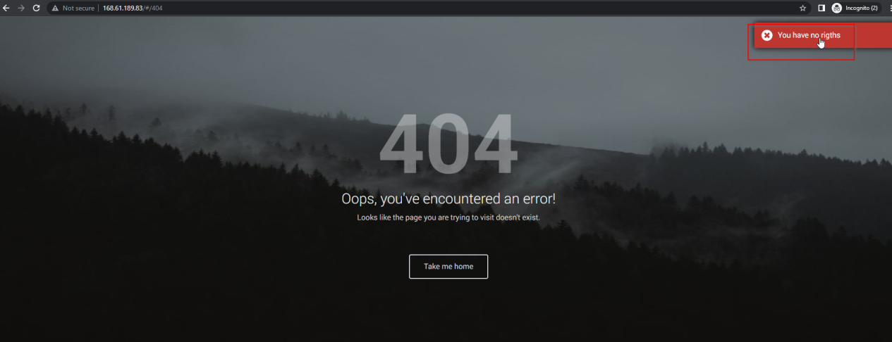

For Facility Off Time module, user having the Manage rights even though do not see the Edit button

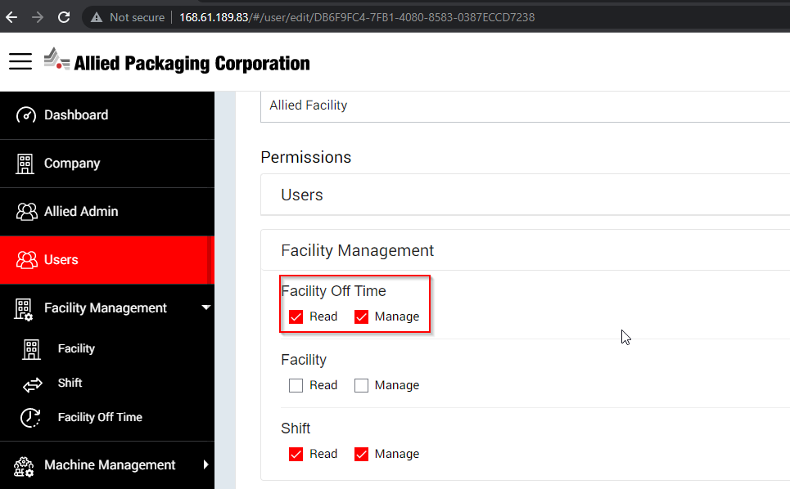

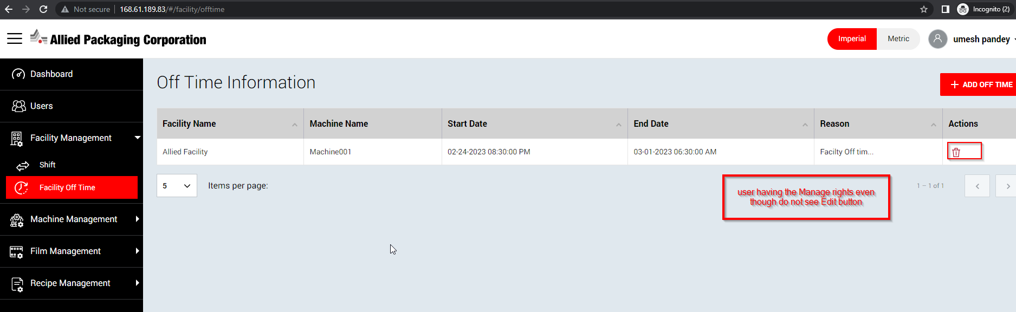

If user having the Read access for Facility Off Time, Read button do not display

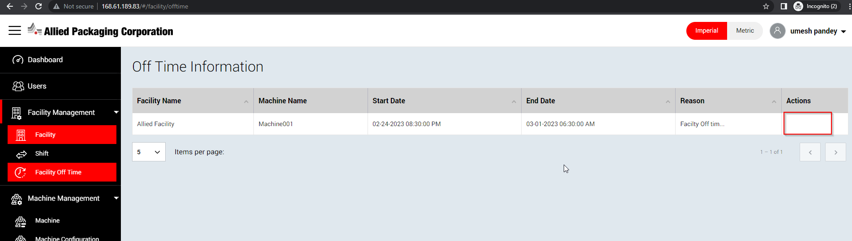

When user don’t have any rights of Facility and login with their own credentials and goto > Facility tab from left, continuously Loader bar displaying

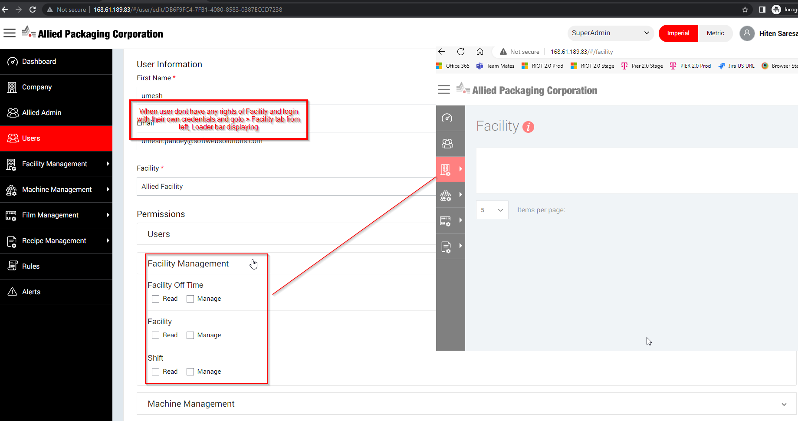

Even though user able to update the Profile details , Company list is empty.

Facility\* drop down should not be selected if do not exist any value in Company\* drop down

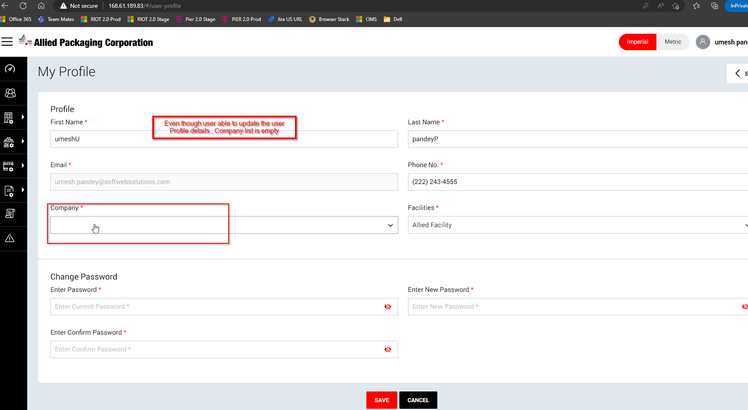

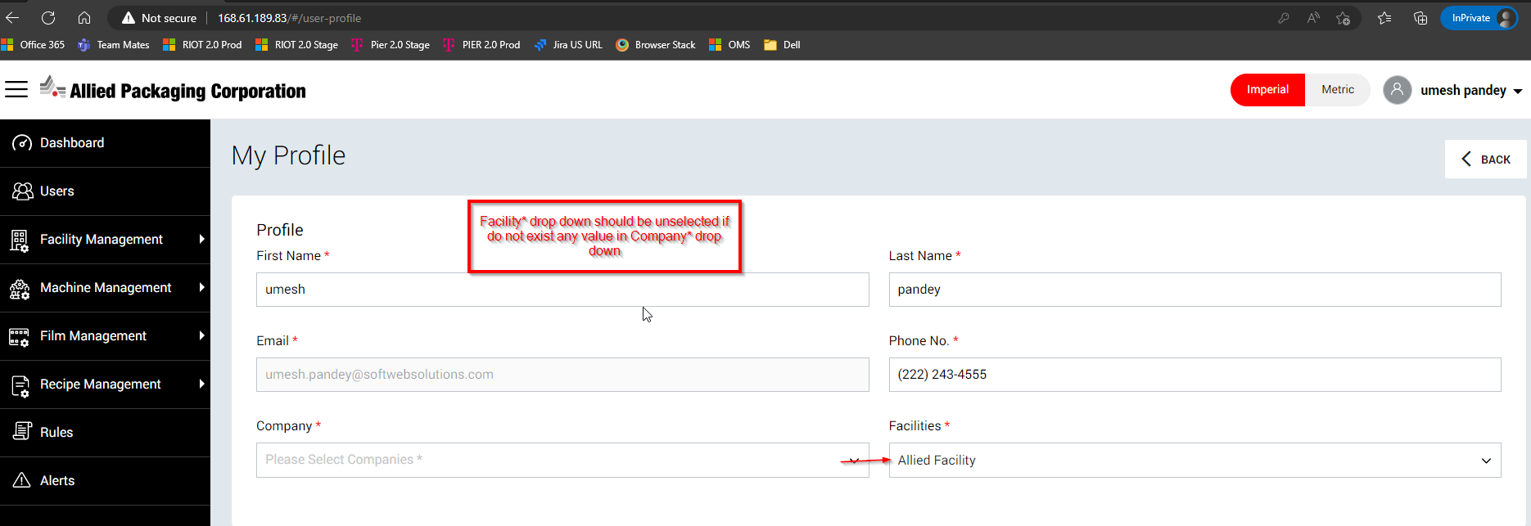

Spelling of "Occured" seeing incorrect in Dashboard > System Alerts section at bottom

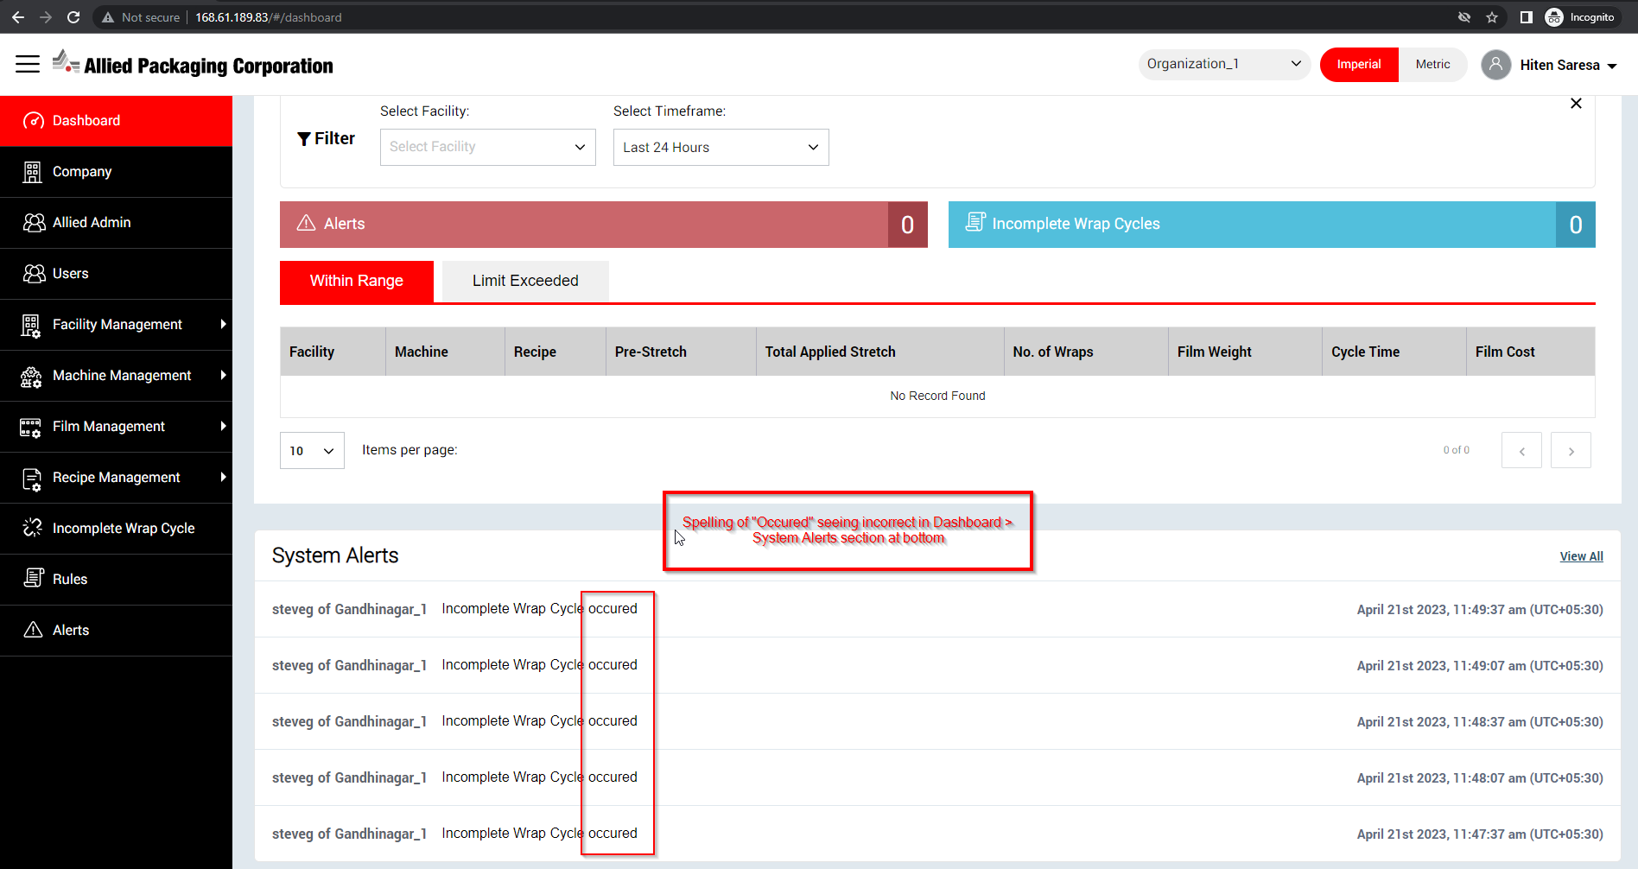

"March Facility" seeing missing on Edit Recipe > Facility drop down while user (umesh pandey) login with their account and goto > Edit Recipe page

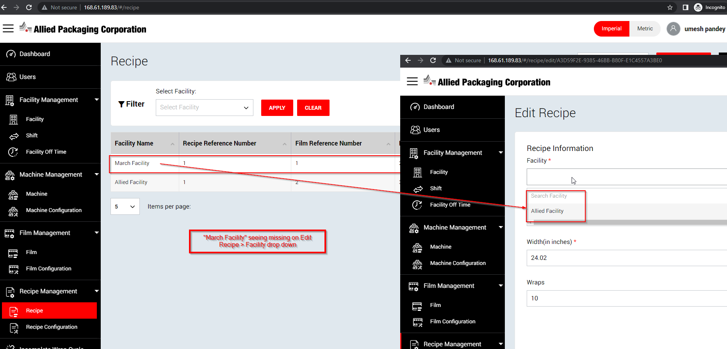

From Incomplete Wrap Cycle page, Search field do not works at top right corner while search with any keyword

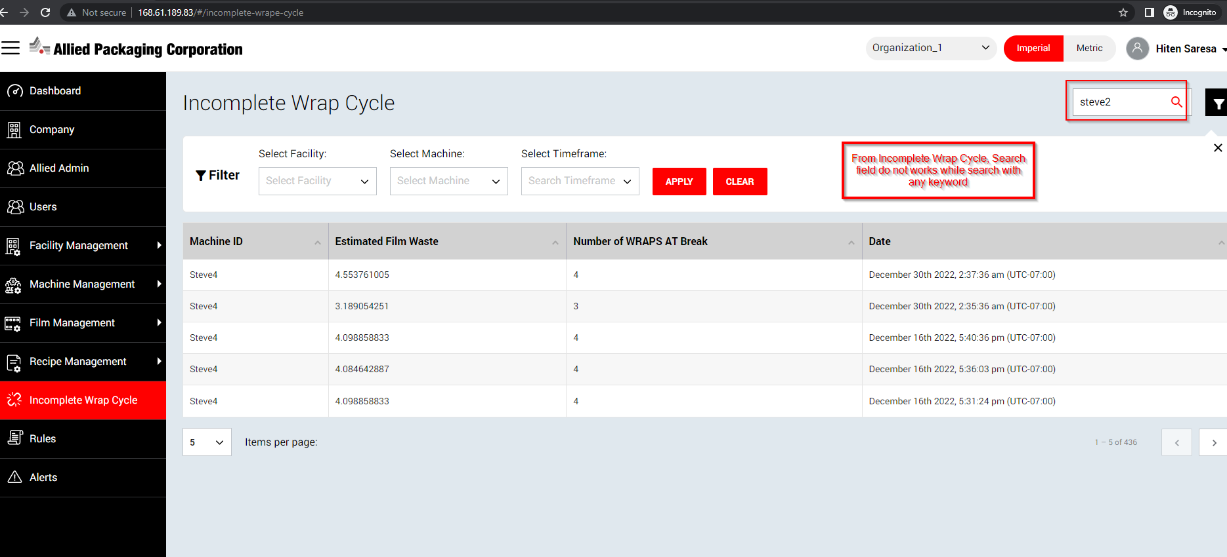

From “Allied Admin / Users” module, “Read / Manage” check box do not save properly while save with both check boxes as check in below highlighted section.

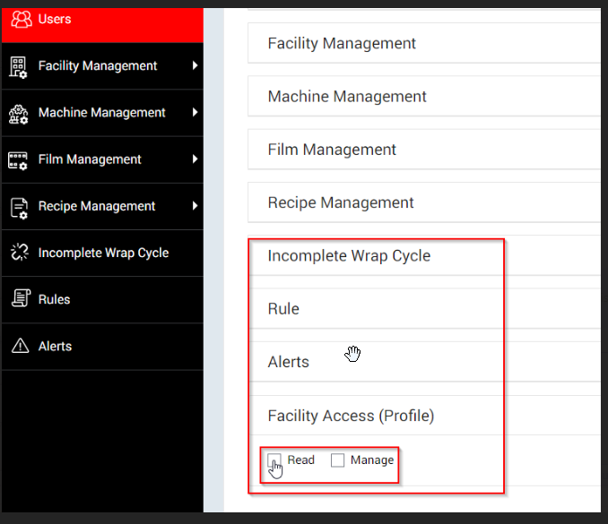

In cross application, drop down list value do not displayed in Ascending order.

